Touching Grass PDA Installation Guide
Live Elimination Targets version 4
This guide installs the Touching Grass target filter in Torn PDA on iPhone or iPad. The script reads Torn’s current team roster, uses a saved FFScouter estimate list, hides opponents at 90 percent of your entered battle stats or higher, and can show only targets Torn currently marks as attackable.

Before you start
- Download the file named Touching Grass PDA Full Live Roster v4.0.0.user.js to the Files app.
- Use the latest available version of Torn PDA.
- No Torn API key is required for this script.

Enable user scripts
- Open Torn PDA and go to Settings.
- Open Advanced Browser Settings.
- Turn on Enable User Scripts.
- Open Manage Scripts.

Import the file
- In Manage Scripts, tap the cog at the top of the User scripts screen.
- Choose Import from File.
- Select Touching Grass PDA Full Live Roster v4.0.0.user.js from the Files app.
- On the Import Options screen, leave the Touching Grass script selected and tap Import.

Import confirmation screen
This is the screen shown immediately before the final Import button is tapped. The selected script should have a green switch.
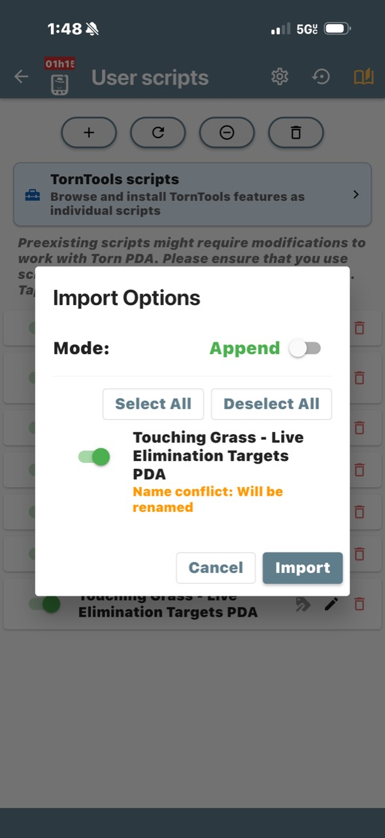
Tap Import in the lower right corner to finish adding the script.

Use the target list
- Open Torn in PDA and go to Elimination.
- Open an opposing team page. Give the roster a moment to load.
- Tap the TG Live Targets button, then tap Open.
- Enter your total battle stats. You can use values such as 350m, 1.2b, or 350000000.
- Leave Only attackable enabled when you want targets Torn currently marks Okay.
- Tap Apply. Tap a column heading to sort the list, or tap Attack beside a target.

What the script shows
- Player name and profile link
- Saved FFScouter battle-stat estimate
- Level and Torn live status
- Current Elimination attack count
- A direct attack link

If the list does not appear
- Confirm Enable User Scripts is still turned on in Advanced Browser Settings.
- Confirm the Touching Grass script switch is green in Manage Scripts.
- Open an opposing team roster before opening TG Live Targets.
- Reload the Elimination page once if the roster was already open during installation.
Important: FFScouter values are estimates from the embedded snapshot. Torn status and roster information come from the live Elimination page.

